Session 12 — Problem B: LED PC13 by pure DMA (HAL, rung 0_1)
STM32F103C8T6 · bare-metal · TIM1_UP → DMA1_CH5 (circular) → GPIOC_ODR · verified on board

Table of Contents

1. Introduction
Problem A showed DMA as a conveyor belt: declare a transfer, press enable, and the hardware copies with the CPU standing aside. But a belt that dumps everything at bus speed is only half the story — most real DMA work is paced by events. A peripheral raises a *DMA request* each time it is ready, and the DMA controller moves exactly one element per request. That is the belt with a metronome.
Why event-paced DMA matters. It is the mechanism behind virtually every periodic I/O pattern in embedded systems: a timer beats, and on every beat one sample moves — no interrupt handler, no CPU wake-up, perfect timing jitter-free at the hardware level:
- Waveform generation — a timer paces DAC (or GPIO) writes from a RAM pattern: audio tones, arbitrary signal generators, WS2812 LED-strip bitstreams.
- PWM pattern engines — timer update events stream new duty-cycle values into CCR registers (motor ramps, LED dimming curves).
- Display scanning — LED-matrix and 7-segment multiplexing at a fixed refresh rate with zero CPU load.
- Periodic sampling — the mirror image: a timer paces ADC conversions into a ring buffer.
Problem B (this report): the smallest possible instance of that pattern on the STM32F103 — blink the on-board LED (PC13) with the CPU fully halted. TIM1 overflows every 400 ms and raises a DMA request (not an interrupt); DMA1 Channel 5 answers by writing the next word of a 2-word pattern into GPIOC_ODR; circular mode reloads the counter forever. The LED blinks even while the debugger holds the core at a breakpoint — the strongest possible proof that the CPU is not involved.
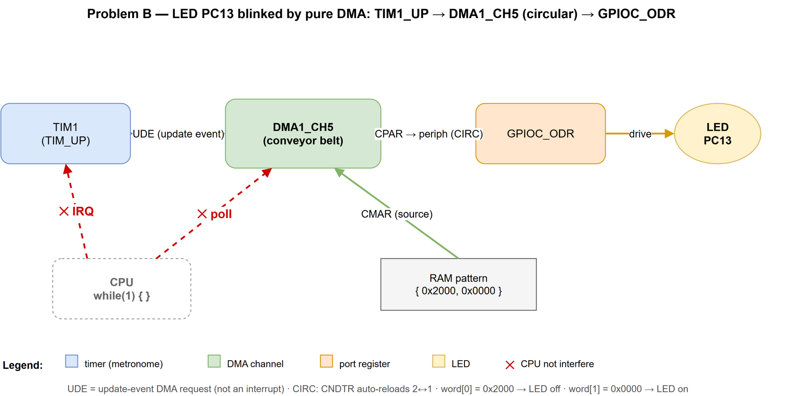
Figure 1. Problem B datapath: TIM1 update event → DMA1 Channel 5 (circular) → GPIOC_ODR → LED PC13; the CPU does not interfere — the transfer is paced by the timer, not by code

2. Problem Identification
Problem A left two questions deliberately open:
- Nobody saw the belt move. mem2mem rips through at bus speed (<1 µs), so every
halt already showed CNDTR = 0. To *watch* DMA work — the counter stepping down, the destination changing — the transfer must be slowed to human speed by an external pacer.
- The peripheral-request side was untouched. Problem A used MEM2MEM, which needs
no request line. Real DMA is driven by peripheral requests routed through a fixed channel mapping (RM0008 Table 78: TIM1_UP is hard-wired to DMA1 Channel 5) and gated by request-enable bits (TIM1_DIER.UDE) — a whole mechanism absent from Problem A.
Problem B closes both gaps, and adds two new register-level concepts on the way:
circular mode (CIRC = 1: CNDTR self-reloads, the transfer never "completes") and memory→peripheral direction with a fixed destination (PINC = 0).
Problem B spans three stages — the same problem re-implemented at three API layers:
Stage | API layer | Status
0_1 | HAL (vendor library) | PASS on board — this report
0_2 | CMSIS (register names) | next
0_3 | raw registers (project DSL per STANDARD.md) | planned

Problem A — the mem-to-mem sibling problem of Session 12 — has its own report; the two share only the session map (section 4.1) and the acceptance method.

3. Objective
Acceptance criteria set before writing any code:
- Build: iarbuild on config DMA_B12_S01_HAL (with PROBLEM_B selected) completes with 0 errors, 0 warnings.
- Function: LED PC13 blinks with a 400 ms half-period — and keeps blinking while the core is halted at a breakpoint (the "CPU not involved" proof).
- Visible countdown: DMA1_CH5.CNDTR can be watched stepping 2 → 1 → 2 in Live Watch — the observation Problem A could not offer.
- Correct pacing chain in registers: TIM1_DIER.UDE = 1 (DMA request, *not* UIE interrupt), TIM1_CR1.CEN = 1, PSC = 7999, ARR = 399.
- Stage-0 rule respected: no polling loop, no interrupt enabled; the CPU contributes nothing after start-up.
- Minimal vendor footprint: compile only the HAL modules strictly required (target: 3 of ≈30 — DMA, TIM, GPIO).
- Evidence captured, not recalled: annotated C-SPY screenshots in Problem_B/assets/; the register set {CCR, CNDTR, CPAR, CMAR} + {CR1, DIER, PSC, ARR} becomes the fingerprint that stages 0_2 and 0_3 must reproduce.

4. Methodology and Progress

4.1 Method — one problem, three API rungs, one fingerprint
Problem B walks the same priority ladder as Problem A: solve at HAL (rung 0_1), re-solve at CMSIS (rung 0_2), re-solve at raw registers (rung 0_3), then diff the register fingerprints — if all three leave the same values in the DMA channel and TIM1 registers, they are provably the same thing at the hardware level.
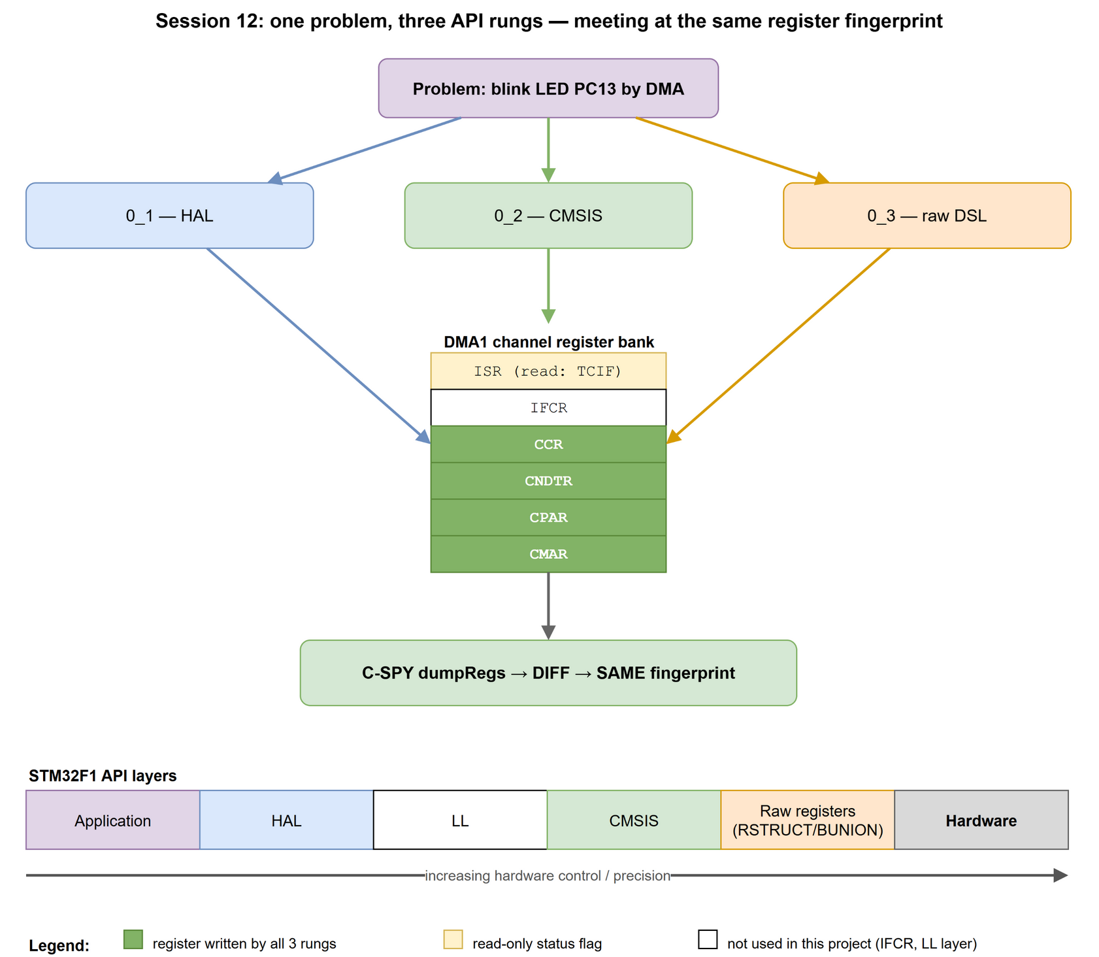
Figure 2. The Session 12 API ladder: the application descends through HAL / CMSIS / raw registers to the hardware; the register bank on the left shows which DMA registers the session touches (green = written, yellow = read); the arrow marks increasing hardware control and precision
Problem B's architecture — the one datapath all three stages must reproduce:
Problem B architecture (shared by stages 0_1 / 0_2 / 0_3)

g_led_pattern[2] @ 0x20000000 GPIOC_ODR @ 0x4001100C
+------------------------+ DMA1 Channel 5 +---------------+ PC13
| RAM: { 0x2000, 0x0 } | =================> | GPIO port C | --> LED
+------------------------+ MEM->PERIPH, word +---------------+ (active-low)
^ MINC=1, PINC=0
| CIRCULAR, N=2
one word per beat
|
+------------------------+
| TIM1 update event | PSC=7999, ARR=399
| DIER.UDE=1 (request, | 8 MHz HSI / 8000 / 400
| NOT an interrupt) | -> one beat every 400 ms
+------------------------+

CPU: while(1) { } -- no polling, no interrupts (Stage-0 rule)
This report covers the (Problem B · rung 0_1 HAL) cell of the session map below; green cells are already verified on the board.
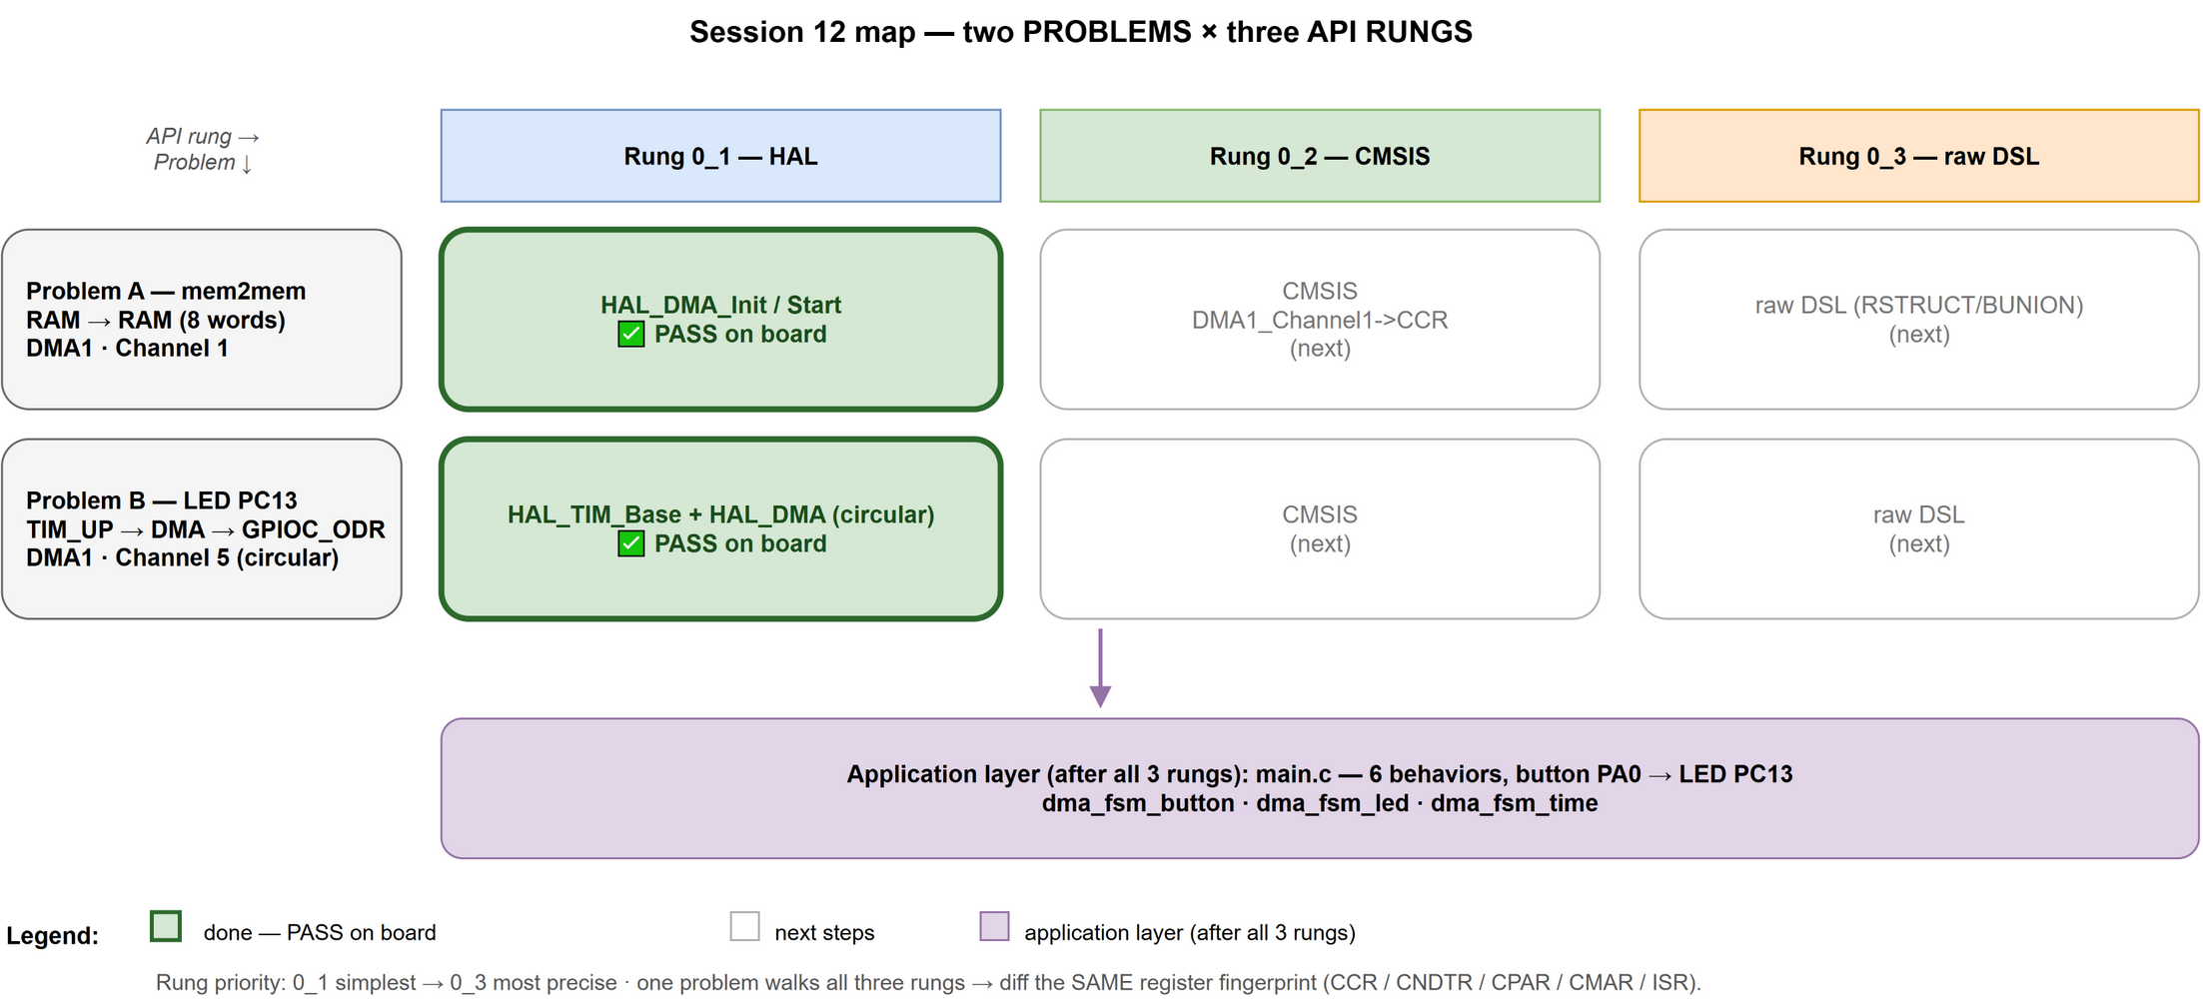
Figure 3. The Session 12 map: two problems × three API rungs; green cells = PASS on board; this report covers the (Problem B · HAL) cell

4.2 Toolchain and build profiles
Hardware and toolchain are identical to Problem A: STM32F103C8T6 (Blue Pill), ST-Link V2 over pure SWD, C-SPY in IAR EWARM 8.3. Problem B reuses the **same build profile
DMA_B12_S01_HAL** (STM32F103xB + USE_HAL_DRIVER); the problem is selected inside the single main_buoi12_dma.c by the label pair PROBLEM_A / PROBLEM_B — the same
#ifdef mechanism that selects the stage. Two more vendor modules join the compile list for this problem: stm32f1xx_hal_gpio.c (pin setup) and stm32f1xx_hal_tim.c (timer base), alongside the stm32f1xx_hal_dma.c already wired for Problem A.
Adding / removing a flag (define). In the IAR GUI: *Project → Options… → C/C++ Compiler → Preprocessor → Defined symbols* — one symbol per line, set per configuration (select the profile in the workspace drop-down first). Adding a line defines the flag for that profile only; deleting the line removes it. The same list is stored per configuration as the <CCDefines> option inside test.ewp, which is why a profile's flag changes show up as reviewable diffs in git.
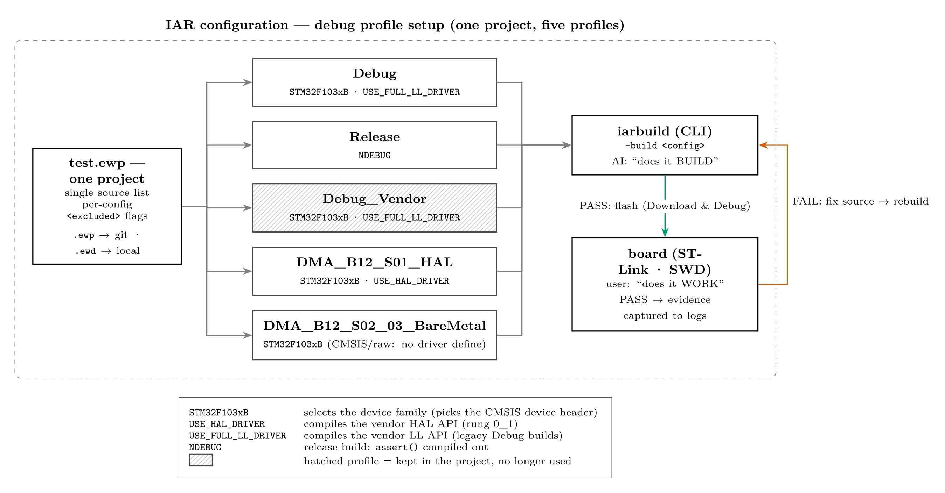
Figure 4. IAR configuration — debug profile setup: one project fans out to five build profiles (only the enabled flags differ; the legend decodes each flag); the hatched profile (Debug_Vendor) is kept in the project but no longer used; all profiles feed iarbuild — PASS flashes to the board, FAIL loops back to fix-and-rebuild

4.3 Implementation (evidence in code)
The pattern is two whole-word ODR images, replayed forever by circular DMA —
[0] = bit 13 set (PC13 high, LED off: the Blue Pill LED is active-low),
[1] = all clear (PC13 low, LED on):
static uint32_t g_led_pattern[2] = { (1uL << 13), 0uL };
The complete Stage 0_1 core — timer as metronome, DMA as belt, one hook between them:
static void Stage01_LedByTimDma(void)
{
/* -- timer: 8 MHz HSI / 8000 = 1 kHz tick, reload every 400 ticks -- */
__HAL_RCC_TIM1_CLK_ENABLE();
htim1.Instance = TIM1;
htim1.Init.Prescaler = 8000u - 1u; /* 1 tick = 1 ms */
htim1.Init.Period = 400u - 1u; /* update event each 400 ms */
htim1.Init.CounterMode = TIM_COUNTERMODE_UP;
htim1.Init.RepetitionCounter = 0u; /* TIM1: fire every reload */
HAL_TIM_Base_Init(&htim1); /* writes PSC/ARR/CR1 */

/* -- DMA: memory (pattern) -> peripheral (ODR), circular, word cells -- */
__HAL_RCC_DMA1_CLK_ENABLE();
hdma.Instance = DMA1_Channel5; /* TIM1_UP lives here */
hdma.Init.Direction = DMA_MEMORY_TO_PERIPH;
hdma.Init.PeriphInc = DMA_PINC_DISABLE; /* ODR never moves */
hdma.Init.MemInc = DMA_MINC_ENABLE; /* walk the pattern */
hdma.Init.PeriphDataAlignment = DMA_PDATAALIGN_WORD;
hdma.Init.MemDataAlignment = DMA_MDATAALIGN_WORD;
hdma.Init.Mode = DMA_CIRCULAR; /* never "done": no TC */
HAL_DMA_Init(&hdma);
HAL_DMA_Start(&hdma, (uint32_t)g_led_pattern, (uint32_t)&GPIOC->ODR, 2u);

/* -- hook them together and press play -- */
__HAL_TIM_ENABLE_DMA(&htim1, TIM_DMA_UPDATE); /* DIER.UDE = 1 */
HAL_TIM_Base_Start(&htim1); /* CR1.CEN = 1 - GO */
/* NO poll, NO interrupt: from here the LED blinks with the CPU halted. */
}
One debugging trick worth recording: DMA1_Channel5 and TIM1 are preprocessor macros, invisible to C-SPY Live Watch. Two __root pointer constants make the whole register structs watchable (*g_dbg_dma5, *g_dbg_tim1) without being dead-stripped:
__root DMA_Channel_TypeDef * const g_dbg_dma5 = DMA1_Channel5;
__root TIM_TypeDef * const g_dbg_tim1 = TIM1;

4.4 Verification method
- Flash via ST-Link, run through start-up, then halt the core — the LED must keep
blinking (hardware-only proof).
- Watch the belt move: in Live Watch, *g_dbg_dma5 shows CNDTR stepping
2 → 1 → 2 → … one step per 400 ms beat, while *g_dbg_tim1 shows CNT ticking.
- Register fingerprint: capture DMA1_CH5 {CCR, CNDTR, CPAR, CMAR} and TIM1
{CR1, DIER, CNT, PSC, ARR}; screenshot with annotations (red = live values, blue = configuration values).
- Keep the fingerprint as the acceptance reference for stages 0_2 / 0_3.

4.5 Progress
Step | Outcome
Add PROBLEM_B branch to main_buoi12_dma.c | done
Register hal_gpio.c + hal_tim.c in test.ewp | done — other configs untouched
Build (DMA_B12_S01_HAL) | 0 errors, 0 warnings
On-board run: LED blinks with core halted | PASS
CNDTR countdown observed in Live Watch | PASS — screenshots in Problem_B/assets/
Stage 0_2 (CMSIS), 0_3 (raw DSL) | not started — next sessions

5. Result and Evaluation

5.1 Register fingerprint — DMA1 · Channel 5 + TIM1
In both screenshots below, red boxes mark live/changing values (CNDTR, CNT — the proof the metronome is beating) and blue boxes mark configuration/fingerprint values (the proof it was set up as coded).
Table 1 — the fingerprint after start-up (read in C-SPY via *g_dbg_dma5 / *g_dbg_tim1):
Register | Value | Meaning
DMA1_CCR5 | 0x00000AB1 | channel configuration (decoded in Table 2)
DMA1_CNDTR5 | 2 ↔ 1 (live) | words remaining — reloads to 2 (circular)
DMA1_CPAR5 | 0x4001100C | destination = &GPIOC->ODR (fixed, PINC=0)
DMA1_CMAR5 | 0x20000000 | source = g_led_pattern[0]
TIM1_CR1 | 0x00000001 | CEN = 1 — counter running
TIM1_DIER | 0x00000100 | UDE = 1 — update-DMA request; UIE = 0 (no interrupt)
TIM1_CNT | 300 / 341 (live) | counting 0…399, one lap = 400 ms
TIM1_PSC | 7999 | 8 MHz / 8000 = 1 kHz tick
TIM1_ARR | 399 | update event every 400 ticks = 400 ms

Table 2 — decoding CCR5 = 0x00000AB1 (contrast with Problem A's 0x00004AC1):
Bit-field | Value | Meaning
MEM2MEM | 0 | not memory→memory — a real peripheral request drives it
DIR | 1 | read from memory, write to peripheral
CIRC | 1 | circular — CNDTR self-reloads, transfer never "completes"
MSIZE / PSIZE | 0b10 / 0b10 | 32-bit (word) elements on both sides
MINC / PINC | 1 / 0 | pattern pointer walks; ODR address stays fixed
TCIE / HTIE / TEIE | 0 | all interrupts off (per the Stage 0 rule)
EN | 1 | channel enabled

→ a 100% match with hdma.Init / htim1.Init in the code of section 4.3.
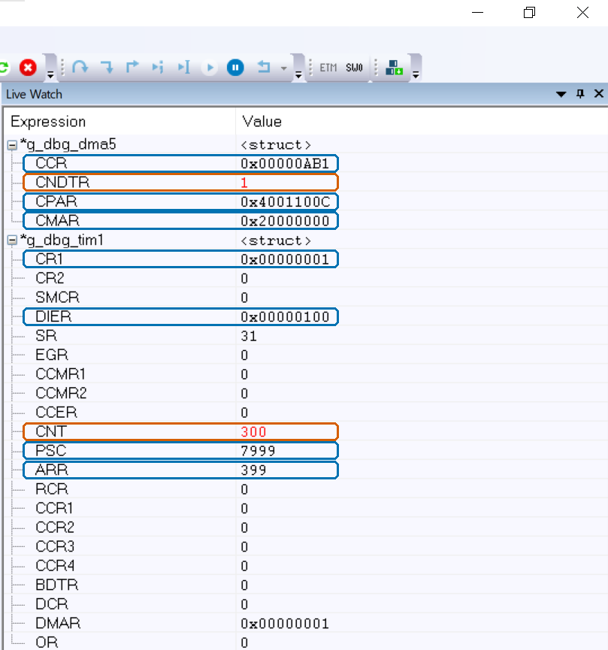
Figure 5. First capture: DMA1 channel 5 mid-pattern — CNDTR = 1 (red, one word left before reload), CCR = 0x0AB1 / CPAR = 0x4001100C / CMAR = 0x20000000 (blue); below, TIM1 with CR1.CEN = 1, DIER = 0x100 (UDE), CNT = 300 ticking (red), PSC = 7999, ARR = 399 (blue)
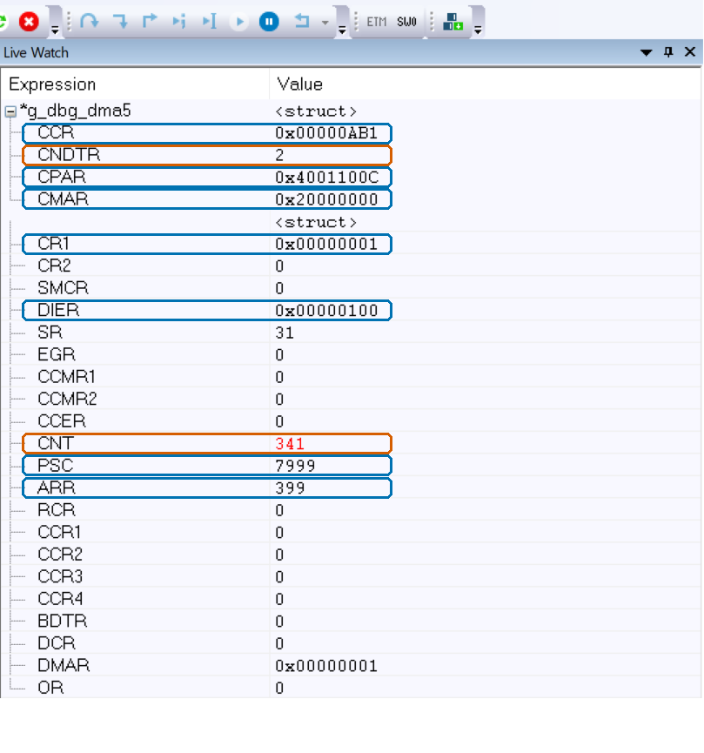
Figure 6. Second capture, moments later: CNDTR has reloaded to 2 (red) — the circular belt restarted by itself; TIM1 CNT = 341 (red) shows the metronome still ticking; every blue configuration value is unchanged

5.2 The decisive observation
Two captures, taken seconds apart, tell the whole story:
- `CNDTR` moved `1 → 2` — it hit zero and *reloaded itself*: circular mode working, one word per timer beat. This is the countdown Problem A was too fast to show.
- `CNT` moved `300 → 341` — the metronome ticks on independently.
- Every configuration register is bit-identical between captures — nothing but the two live counters changes, because nothing but the hardware is running: the core was halted the entire time, and the LED kept blinking.
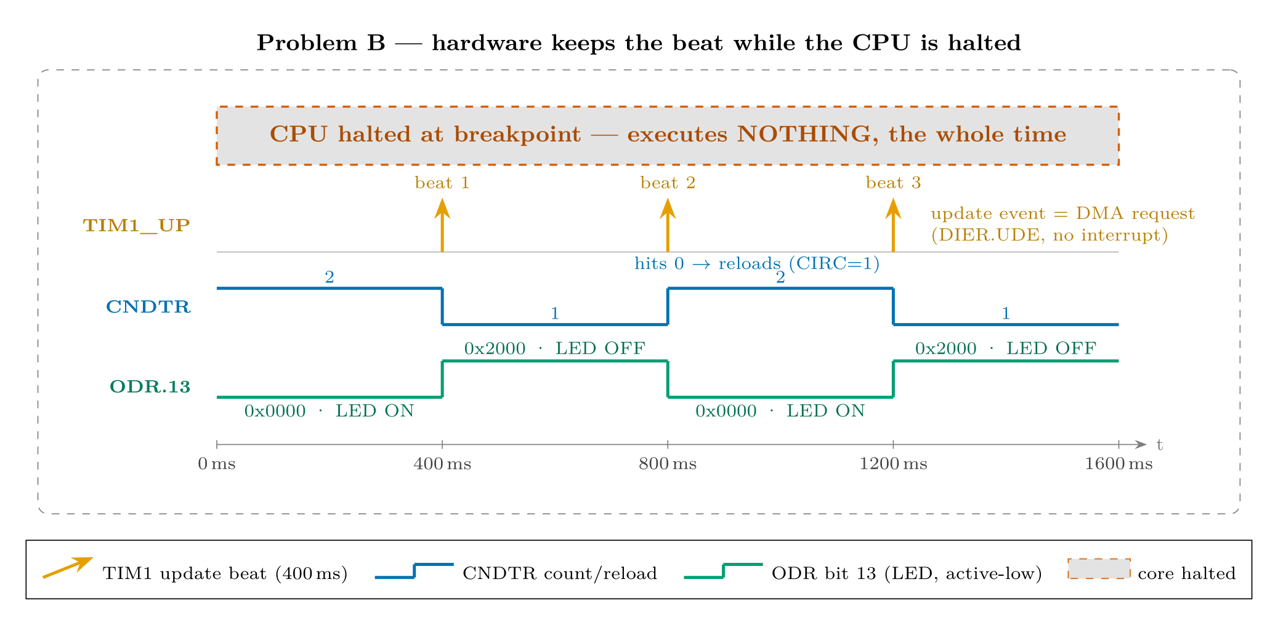
Figure 7. Timing reconstruction of the observation: TIM1 beats every 400 ms (orange = update event, a DMA request via DIER.UDE — no interrupt); CNDTR steps 2 → 1 and self-reloads when it hits 0 (CIRC = 1); ODR bit 13 toggles the active-low LED — all inside the gray band where the core sits halted at a breakpoint, executing nothing

5.3 Evaluation against the objectives
Objective (section 3) | Verdict
Build 0 errors / 0 warnings | met
LED blinks at 400 ms half-period with core halted | met (on-board run)
CNDTR countdown visible, 2 → 1 → 2 | met (screenshots, section 5.1)
Pacing chain: UDE=1, UIE=0, CEN=1, PSC=7999, ARR=399 | met (Table 1)
No polling, no interrupts | met (DIER.UIE = 0, TCIE/HTIE/TEIE = 0, empty while(1))
Minimal vendor footprint (3/≈30 modules) | met — DMA + TIM + GPIO only (section 5.4)
Evidence captured; fingerprint recorded for 0_2 / 0_3 | met (Tables 1–2 are the reference)

5.4 Vendor-API footprint
Problem B needs three HAL modules instead of one — stm32f1xx_hal_dma.c,
stm32f1xx_hal_tim.c, stm32f1xx_hal_gpio.c (3 of ≈30, ~10%) — and five public functions plus two macros: HAL_GPIO_Init, HAL_TIM_Base_Init, HAL_TIM_Base_Start,
HAL_DMA_Init, HAL_DMA_Start, __HAL_TIM_ENABLE_DMA, __HAL_RCC_*_CLK_ENABLE. Still an ignition switch, not a dependency: every one of these maps to a handful of register writes that stages 0_2/0_3 will perform directly.
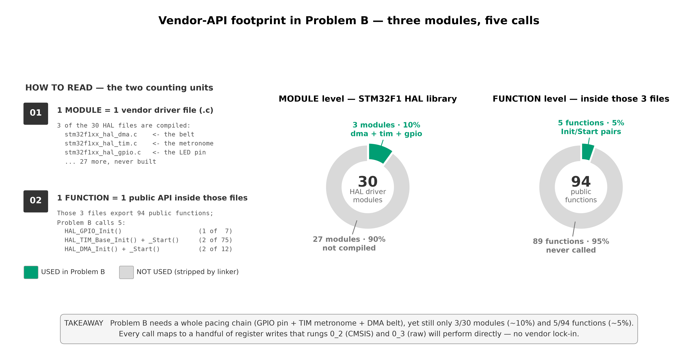
Figure 8. Vendor API usage in Problem B, with the two counting units defined by example: 1 module = 1 vendor driver file (3 of 30 compiled: hal_dma + hal_tim + hal_gpio, ~10%); 1 function = 1 public API inside those files (5 of 94 called: HAL_GPIO_Init, HAL_TIM_Base_Init/Start, HAL_DMA_Init/Start, ~5%); green = used, gray = stripped by the linker

5.5 Lessons learned
- A DMA request is not an interrupt. TIM1_DIER has two separate enable bits:
UIE (update *interrupt* → CPU runs a handler) and UDE (update *DMA request* → hardware moves data, CPU untouched). Problem B sets only UDE — the LED blinks with zero software execution.
- DMA channels are hard-wired to peripherals. TIM1_UP can only arrive on DMA1
Channel 5 (RM0008 Table 78); the channel is chosen by looking it up, not by preference.
- Circular mode redefines "done". With CIRC = 1 there is no transfer-complete
state to wait for — CNDTR reloads forever. The Problem A habit of "check TCIF, check CNDTR == 0" simply does not apply.
- Word-writes to `ODR` rewrite the whole port. The 2-word pattern clears every
other PORTC bit each beat — harmless here (PC13 is the only pin wired), but a real application would use BSRR set/reset semantics instead.
- The Blue Pill LED is active-low: bit13 = 1 turns it *off*. Getting the pattern
order wrong costs nothing but confusion — worth one comment in the code.
- `__root` debug pointers make macro-peripherals watchable. DMA1_Channel5 is a
cast constant, not a symbol; a __root pointer variable gives C-SPY a real object to expand, and survives the linker's dead-stripping despite being referenced by nothing.

6. References
- STMicroelectronics, *RM0008 — STM32F101xx/102xx/103xx/105xx/107xx Reference Manual*: ch. 13 "DMA controller" (Table 78 — DMA1 request mapping: TIM1_UP → Channel 5), ch. 14 "Advanced-control timers (TIM1)" (CR1, DIER.UDE, PSC, ARR).
- STMicroelectronics, *STM32F103x8/B Datasheet* — local copy: docs/datasheets/stm32f10xxx.pdf.
- STMicroelectronics, *UM1850 — Description of STM32F1 HAL and low-layer drivers* (HAL_DMA, HAL_TIM, HAL_GPIO APIs).
- Vendor driver sources: stm32f1xx_hal_dma.c, stm32f1xx_hal_tim.c, stm32f1xx_hal_gpio.c (STM32CubeF1 package, mirrored in this repository).
- Project coding standard: STANDARD.md (register-map DSL used at rung 0_3).
- Captured on-board evidence: Buoi_12/Problem_B/assets/ (fig_12_B_S01_CNDTR_countdown.png, fig_12_B_S01_CNDTR_reload.png, annotated).
- Sibling report: *Session 12 — Problem A: DMA mem-to-mem (HAL, rung 0_1)* — Buoi_12/Problem_A/docs/report_Buoi_12_Problem_A_EN.docx.
List of Figures

